

Web Datamining and Semantics

Project





Pierre PETILLION Tom PAYET

Dany PERENCHIO Elie OBADIA

DIA 6

**Pierre PETILLION Tom PAYET**

**Dany PERENCHIO Elie OBADIA**

DIA 6

Sommaire

Introduction 3

Use our website 4

How to install 4

How to use 4

Our work 6

Modelling the ontology 6

Populating the ontology 6

Querying the ontology 7

Manipulating the ontology using Jena 7

Conclusion 8

Self-assessment 8

# Introduction

For this semester, we had to make an application that consisted in integrating knowledge that we acquired during practical works.

Our application had to include geospatial and dynamic data. We also had to use an ontology to describe entities we had to store.

The objectives were to learn how to interact with RDF files, that gather information from different sources.

We had to choose a subject, in which we could use multiple APIs. We decided to make a website on which customers could see information about train they have booked, like departure and arrival station, departure and arrival time, and weather in both cities.

To achieve this project, we decided to use :

* A dataset provided by SNCF including a lot of information about stations
* The official SNCF API, to get real time information about train journeys, and their train stations
* The Infoclimat API to get the real time weather.

# Use our website

## How to install

The simplest way to test our project is to go on [http://5.196.8.241:8092/#](http://5.196.8.241:8092/) website. This doesn’t require any installation.

If you want to install manually our project, you need to get the zip file corresponding to the project and to open it in a code editor supporting Node JS, like Visual Studio Code.

Go into the “Site” folder in a terminal, and type “npm start run”. If you are missing some modules, install them with “npm install”.

When the server started, go on <http://localhost:8092/>. You can now use the website.

## How to use

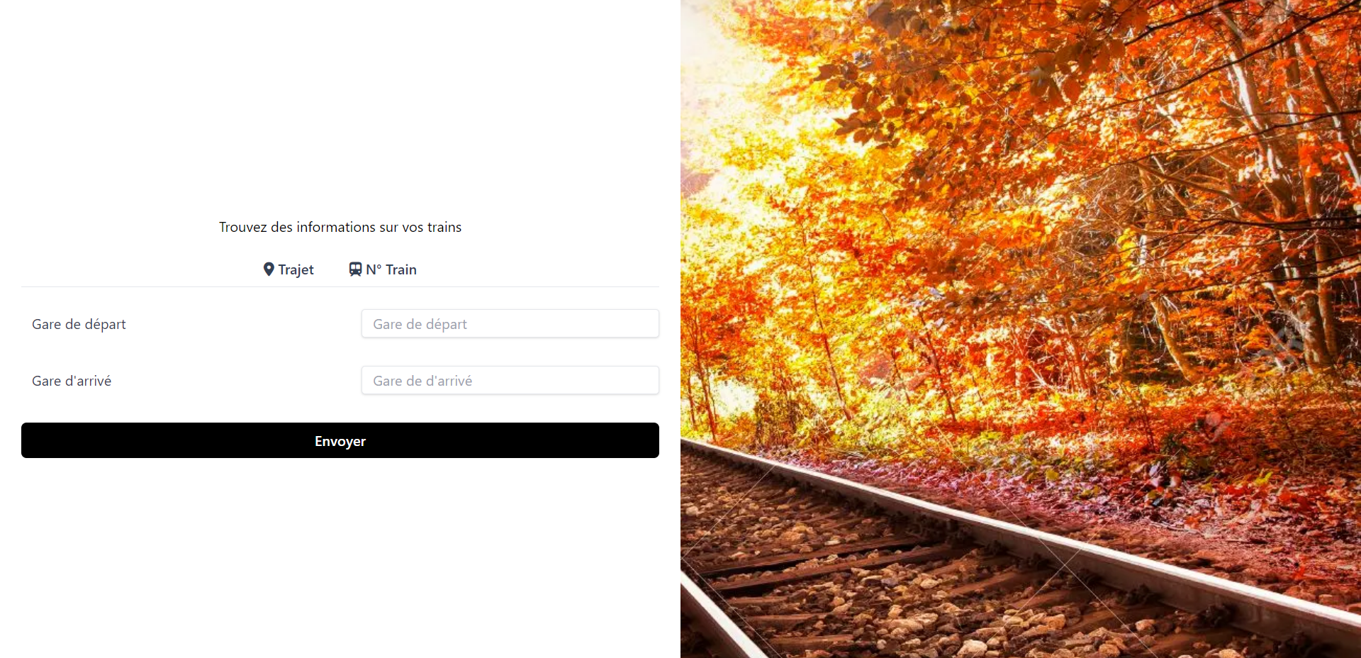

When you are on the website, you have 2 tabs, “Trajet” and “N° Train”.

The tab “Trajet” allows to find a specific trip by entering departure and arrival stations.

The “departure station” field has auto-completion to make it easy to enter a station name.

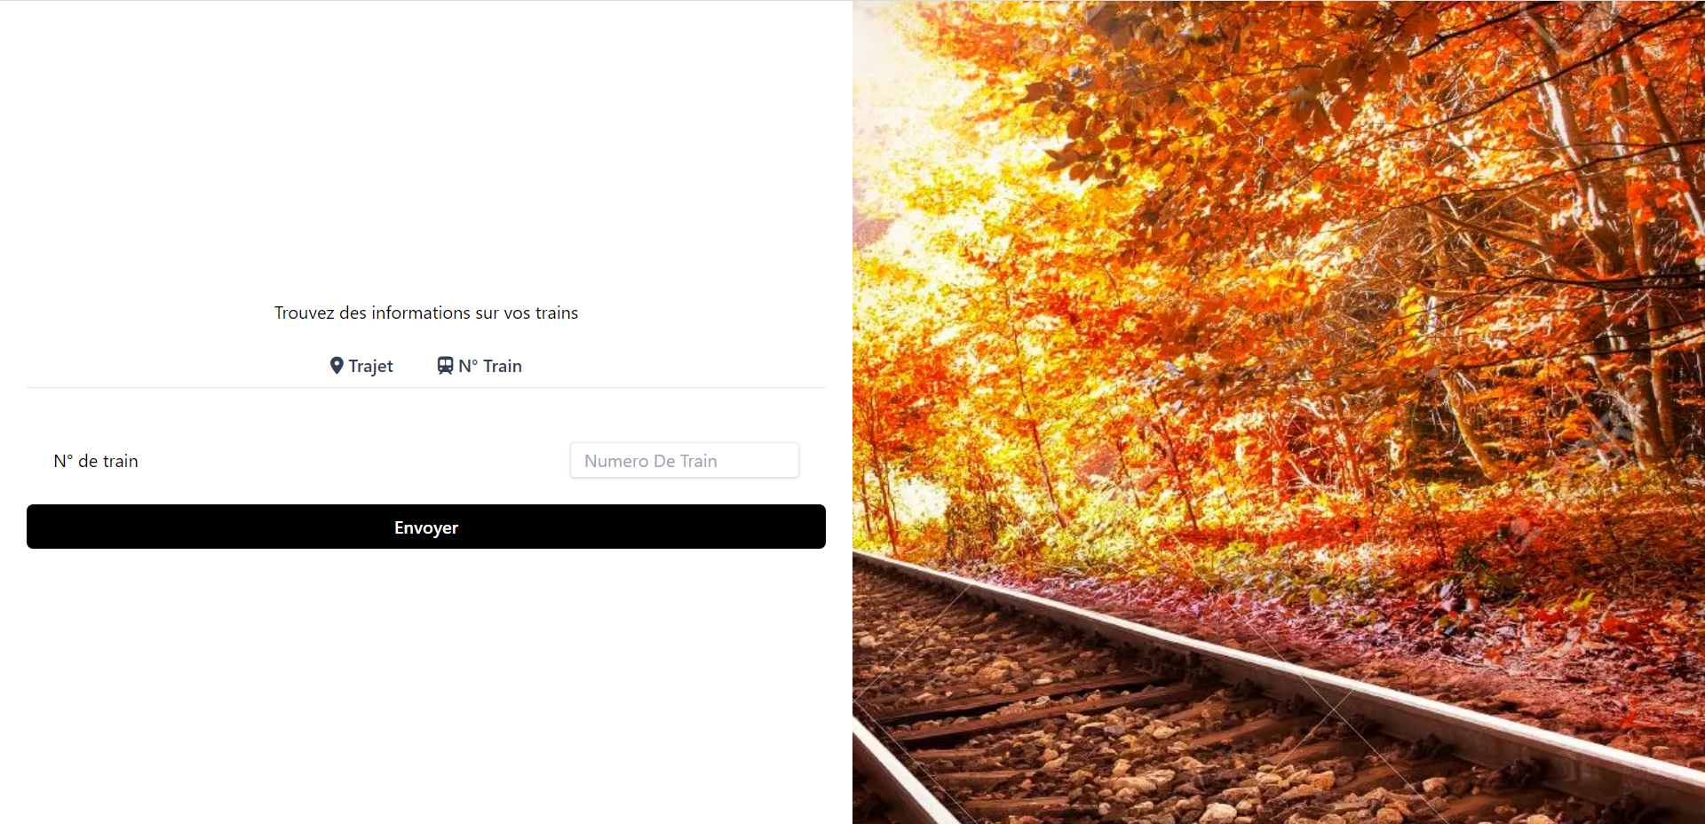

The “N° Train” tab allows to find a specific trip by entering the train number provided by SNCF.

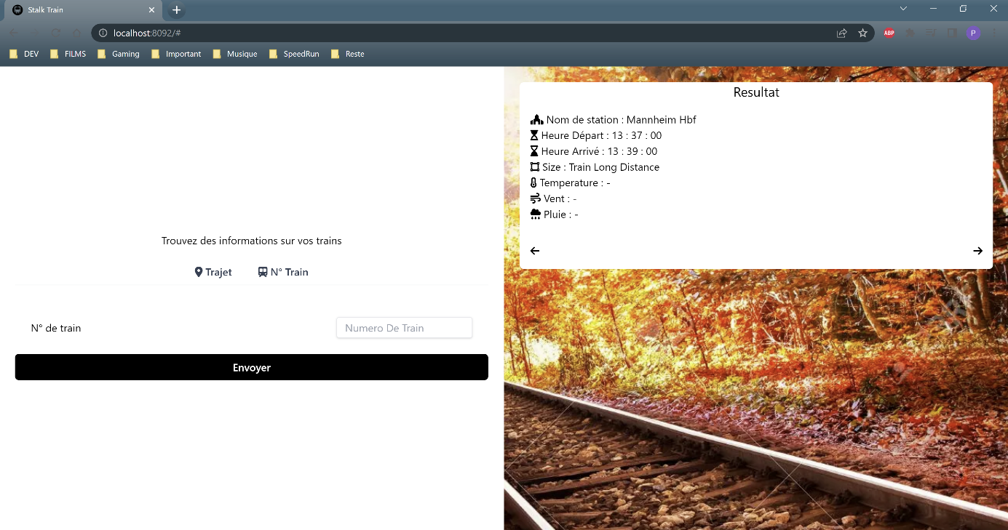

In both cases, when you entered information, you can see information about his trip, as station name, departure and arrival time, and also temperature, wind and rain at the place where you want to go.

# Our work

## Modelling the ontology

First, we modelled our ontology in Protege in order to gather all the information we needed in one place.

In this ontology, we put all the information needed to include in our database. So we put information about trains, train stations, coordinates and weather.

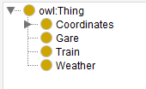

We also created data properties to add information to classes we created. We put a domain and a range to each of these properties, to explain what class they belong to, and data types.

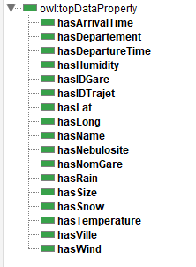

We also created some individuals to illustrate how to use this ontology.

## Populating the ontology

We used a dataset giving information about stations, including coordinates.

We imported this dataset, and then used the library jsonld to change it into an RDF file. To do this, we also used a JSON-LD file that allowed to convert names of variables into those ones we wanted.

With this method, we obtained a triplestore written with n-quads syntax.

When it comes to APIs, we decided to use the SNCF and a weather API to show information about the trip and the weather, we coded manually the conversion to RDF file, as it was too complicated otherwise.

## Querying the ontology

As we used JavaScript to connect with our HTML for our website, we used rdfstore to make SAPRQL queries.

These queries are connected to user requests and are triggered automatically when he clicks on the ‘send’ button.

## Manipulating the ontology using Jena

As we are 4 students working on this project, we decided to make a web application to query the data. Moreover, this is more user friendly, as the user knows intuitively how to use our website.

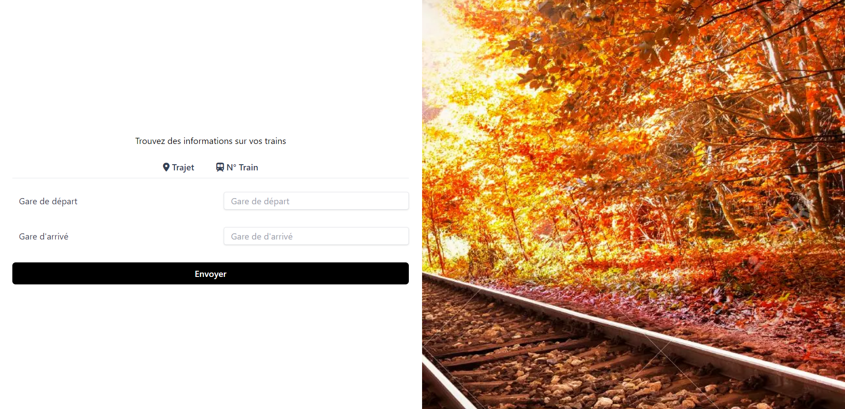

As you can see, the user can choose to put his departure and arrival stations to get information about his trip, or alternatively enter the number of his train.

# Conclusion

This project allowed us to work on a mini website, applying knowledge we acquired in class. We decided to use JavaScript to make the connexion with HTML easier, but using JavaScript made much harder the usage of libraries, especially to deal with RDF conversions, or SPARQL queries.

Unfortunately, as we were short of time, we couldn’t get a perfectly functional website.

However, this project allowed us to improve our skills in web programming, and to deal with OWL format.

## Self-assessment

Part 1 (4 pt) : 3.5

classess and properties (2 pt) : 2

restrictions and defined classes (1pt) : 1

Extern ontology reuse (1 pt) : 0.5

Part 2 (4 pts) : 4

individuals (1pt) : 1

JSON-LD (2pt: more than 2 sources, 1pt: one source only); 2

JSON-LD more than one entity (class) (1pts); 1

Part 3 (4 points) : 2.25

SPARQL (3 pts), 2

SWRL (1 pts) 0.25

Part 4 (8pts) : 4

Entity search (POI, travellers, trip)--->(1 pts each : 3pts); 2

Advanced functionnalty (could trip computation, or any other advanced finctionnalty such trip computattin or traveller history) -->(2pts); 0

any other information associated to POI such as weather forcasting (or another entity) --> 2pts; 1

result export in RDF or JSON-LD (1pt) : 1

Bonus : 7

triple store (2pts); 1

GUI (2pts) : 2

RDFA (1 pt) : 1

realtime dynamic data update (2pt) : 2

Deployment on server : 1

Total : 20.75